30 Mar 15 - 11:12

Safety and Shipping Review 2015

Report by Allianz unveils trends and developments in shipping losses and safety during 2015

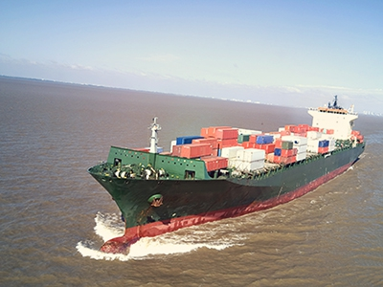

Allianz Global Corporate & Specialty (AGCS) issued an annual review of trends and developments in shipping losses and safety, entitled as 'Safety and Shipping Review 2015'. This review focuses on key developments in maritime safety and analyzes shipping losses (of over 100 gross tons) during the 12 months prior to December 31, 2014. It follows the Safety and Shipping Review 2014, available here

Highlights
- 75 large ships lost worldwide in 2014, down by a third year-on-year
- South China and South East Asian waters top loss hotspots
- Increasing size of container ships and floating offshore facilities could cause larger losses exceeding $1 billion
- Cyber risks a growing concern in shipping sector, particularly around e-navigation
- Crewing levels, Arctic shipping, the increase in human trafficking by sea and further geopolitical uncertainty create new industry risks

Shipping losses continued their long-term downward trend with 75 reported worldwide in 2014, making it the safest year in shipping for 10 years, according to Allianz Global Corporate & Specialty SE's (AGCS) third annual Safety and Shipping Review 2015, which analyzes reported shipping losses of over 100 gross tons.Safety
Losses declined by 32% compared with the previous year and were well below the 10-year loss average of 127. Since 2005 shipping losses have declined by 50%. More than a third of 2014's total losses were in two maritime regions. South China, Indo China, Indonesia and the Philippines (17 ships) and Japan, Korea and North China (12 ships). Cargo and fishing vessels accounted for over 50% of all losses.
The most common cause of total losses is foundering (sinking/submerging), accounting for 65% of losses in 2014 (49). With 13 ships wrecked or stranded, grounding was the second most common cause with fires/explosions (4) third, but significantly down year-on-year.
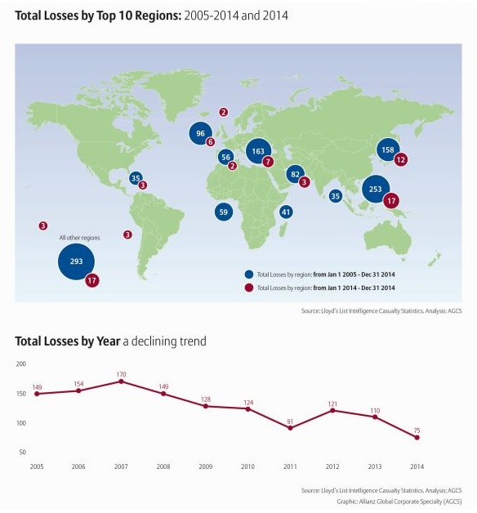
According to the report, there were 2,773 shipping incidents (casualties) globally (including total losses) during 2014. The East Mediterranean & Black Sea region was the top hotspot (490), up 5% year-on-year. The British Isles, North Sea, English Channel and Bay of Biscay ranked second (465), up 29%, and was also the top incident hotspot over the past decade. December is the worst month for losses in the Northern Hemisphere and August in the Southern Hemisphere. For every total loss in the Southern Hemisphere there are 7 in the Northern Hemisphere.
One vessel in the Great Lakes region of North America lays claim to the title of unluckiest ship. Analysis shows it has reportedly been involved in 19 incidents in the past 8 years - including six in one year. It has suffered a fire, engine failure, steering failure and even hit a submerged log.
Passenger ship safety and crew levels in the spotlight
While the long-term downward trend in shipping losses is encouraging, recent casualties such as Sewol and Norman Atlantic have once again raised significant concerns over training and emergency preparedness on passenger ships three years after the Costa Concordia disaster. Seven passenger ships were lost during 2014, accounting for almost 10% of total losses. "In many cases construction of the vessel is not the only weak point. These two incidents underline a worrying gap in crew training when it comes to emergency operations on ro-ro ferries or passenger ships," said Sven Gerhard, Global Product Leader Hull & Marine Liabilities, AGCS.
The general shipping trend for smaller crews means seafarers are being asked to do more with less. Minimum manning levels reduce the ability to train people onboard, which can provide invaluable insight and should not become the normal day-to-day level for safe operations.
How big is TEU big?
Container ship safety is also under the spotlight with ever-increasing ship sizes, as evidenced by the January 2015 inauguration of the world's largest container ship, the MSC Oscar (19,224 TEU). The length of four football pitches, it can carry 19,000 containers. Yet ships as large as 22,000 teu are expected to be in service soon. "Larger ships can also mean larger losses. The industry should prepare for a loss exceeding $1 billion in future featuring a container vessel or even a specialized floating offshore facility," Gerhard said. Maximum exposure would not necessarily be limited to vessel and cargo value but could also include environmental or business interruption backlash. This raises concerns about whether risk management needs reviewing after an 80%+ container ship capacity increase in a decade.
AGCS sees a number of risks for such mega-ships including the fact operation is limited to a small number of deep water ports, meaning an increased concentration of risk. There is also a world-wide shortage of qualified seaman. Salvage and removal is also challenging. As the wreck removal of the Costa Concordia passenger ship demonstrated such costs can easily be a multiple of the hull value. "The shipping industry should think long and hard before making the leap to the next ship size," added Captain Rahul Khanna, Global Head of Marine Risk Consulting, AGCS.
Click here to view relevant infographic

Port and ships become hacker targets
Cyber risks represent another new threat for a shipping sector which is highly interconnected and increasingly reliant on automation. "Cyber risk may be in its infancy in the sector today, but ships and ports could become enticing targets for hackers in future. Companies must simulate potential scenarios and identify appropriate mitigation strategies," said Khanna. "A cyber-attack targeting technology on board, in particular electronic navigation systems, could possibly lead to a total loss or even involve several vessels from one company," said Gerhard. Other scenarios include cyber criminals targeting a major port, closing terminals, or interfering with containers or confidential data. Such attacks could also result in significant business interruption costs, notwithstanding liability or reputational losses.

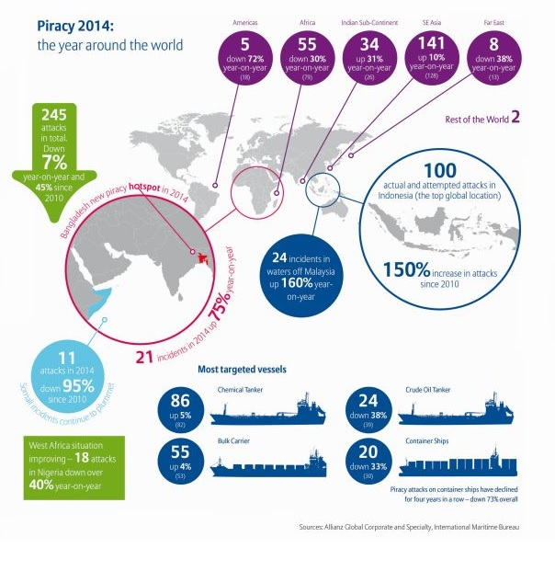

Polar Code welcomed, but need for constant revision
The shipping industry has welcomed the recent arrival of the Polar Code which aims to curb risks from increased traffic in the Arctic and Antarctica. Analysis shows there were 55 reported shipping incidents in Arctic Circle waters during 2014 including one total loss. There were just 3 in 2005. While the code addresses many safety issues, questions remain, particularly around crew training, vessel suitability and potential clean-up. The Polar Code will need constant revision. Any shipping problems encountered and best practices to employ should be outlined at the end of each season.

Further risk challenges
Other risks identified in the 2015 Safety & Shipping Review include:
Overreliance on electronic navigation: The collision of the cargo ship Rickmers Dubai with an unmanned crane barge in 2014 is an example of the perils of overreliance on e-navigation. Training standards around systems such as Electronic Chart Display and Information System (ECDIS) are mixed. "Officers need robust training in order to avoid misinterpretation of ECDIS and operating mistakes that could lead to expensive disasters. Beyond that manual navigation aids and skills are still crucial," said Khanna.
Rise in geopolitical uncertainty: The recent rise in geo-political tension around the world is concerning. The increase in human trafficking of refugees by sea creates search and rescue issues. More than 207,000 migrants crossed the Mediterranean in 2014, driven by the civil war in Syria. The International Maritime Organization estimates at least 600 merchant ships were diverted in 2014 to rescue people, stretching resources and rescue infrastructure. Conflicts in the Middle East also put increasing pressure on the supply chain. Ships should not underestimate the security risks.
Piracy risks move from Africa to Asia: Although there has been good progress tackling activity in Somalia and the Gulf of Guinea, ensuring global attacks (245[1]) are down for a fourth year in a row, piracy thrives elsewhere. Attacks in South East Asian waters are up year-on-year, as are incidents in the Indian subcontinent, with Bangladesh a new hotspot.
Further details may be found by reading 'Safety and Shipping Review 2015'report issued by AGCS (please click at image below)
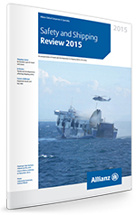
Source: AGCS

Tags: reports, maritime security, shipping industry, maritime safety, Polar Code,pirates threat, passenger ship safety

