Safety & Security

News insight: Master recounts migrant rescue
Girija Shettar
27 April 2015
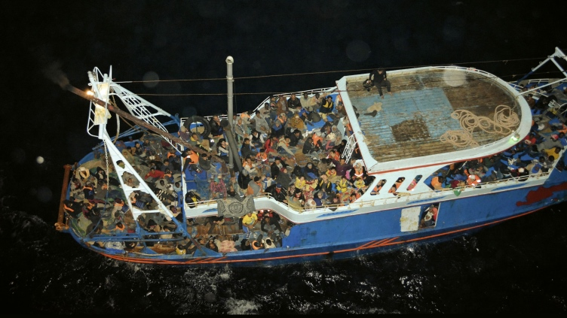

The migrant boat. Photo: Campbell Shipping

A Campbell Shipping fleet ship recently plucked to safety three fishermen who were stranded on their capsized vessel in South Africa.It is the type of rescue that commercial ships routinely carry out, and the obligation for which is written into maritime regulations.

On 22 October 2014, Campbell's handy size dry bulk carrier, CS Caprice, undertook a very different kind of rescue. At 13.52, the vessel received a call from the Maritime Rescue Centre in Malta requesting it divert immediately and to go the aid of a boat in distress that was carrying 300 to 400 people.

In fact, aboard the stricken vessel were 510 men, women, children, babies, and elderly from Syria, Libya, and the African continent; by contrast, there were just 20 crew members on board CS Caprice, which was led by Captain Joshua Perris Bhatt.
Putting in a call to the company, Capt Bhatt received the following guidance from Campbell Shipping's designated person ashore, Captain Rajesh Dhadwal: "Inspire your crew to do this."

Speaking to IHS Maritime, Capt Dhadwal said that while the crew had reservations and concerns, large-scale rescues cannot be done with a utilitarian mindset.
"The human spirit has to lift itself to another level. You cannot attempt this scale of operation if you are thinking about compensation or 'what if the migrants have Ebola?' or 'what if there are terrorists among them and they take over the ship?' You have to put aside the 'what ifs'," he explained, adding that quickly deteriorating weather conditions meant the crew had just "a matter of hours" to assist hundreds of ordinary people up a 6 m freeboard.
"Compare this to the amount of time it takes to board a plane," he said, describing the challenge they faced.

In the event, the rescue was successful. "Not a single life was lost," said Capt Dhadwal, and several medical emergencies were successfully attended to, including one critically ill female passenger. The crew kept her alive via the ship's medical oxygen supply until the Italian coastguard airlifted her to hospital. It is thought to be the largest rescue operation by a single commercial ship in the Mediterranean Sea to date.

But the toll on the crew and the ship's schedule was exceptional. This was not the more usual three- to four-hour rescue; it lasted nearly three days.

Unable to disembark at one port due to inclement weather, the ship carrying 510 distressed migrants was requested to move to another.

"Our schedule was delayed by four days, and the crew was working with the passengers continuously," said Capt Dhadwal, who added that the charterers refused to pay for the days off-hire or the bunkers. The shipping company was also penalised by its insurer following a successful claim for the clean-up of the ship.

"We got the claims back, but it came as a deductible and was mentioned in our claim record. We asked them: 'how can you put this on our claim record and penalise us for doing the right thing?'" Capt Dhadwal said. However, he said the insurer is looking positively on the matter and he is hopeful the decision will be reversed.
The rescue operation depleted the ship's resources. "Every bed sheet, towel, blanket, every single grain on that ship was used. It had stock for 20 people for a month, not 510 people for three days," the captain said.

But the key reason for the insurance claim was the post-rescue ship clean-up effort, which had left it a hazardous mess. "We had to get the ship cleaned, fumigated," he said. "It was full of garbage. All the towels had to be removed, new bedsheets were needed, plus there was vomit, urine, and we needed to get medical checks for the crew."

The ship also had to claim for the cost of calling at more than one port and for the pilotage.

Despite the inconvenience, financial loss, and very real health and safety risks, Capt Dhadwal said ships should continue in their role as rescuers because they have a "global reach" that coastguards do not have.

But shipping needs support, Capt Dhadwal said, in the form of both "diplomatic arrangements" on where migrants should be taken once rescued and official naval leadership during rescue operations.

Currently, ship crews can be left in the dark as to where rescued refugees will be disembarked, which puts the vessel at both legal and physical risk.

"When we picked up that group of 510 people, we did not know where we would be able to take them; we did not know how long they would be with us," he said, explaining that this put the ship and the company at two major risks: the boat refused to be rescued unless the destination was Italy, and yet the ship was under a legal obligation to carry out the rescue; and second, the passengers could mutiny if the ship headed to the 'wrong' port.

To cover themselves legally, Capt Dhadwal ordered Capt Bhatt to record the ship's request to the migrant boat to come alongside to be rescued. Meanwhile, Capt Dhadwal rapidly pursued port options with MRCC Malta.

"We need clear guidelines explaining: in the Mediterranean Sea, within these boundaries, migrants should be taken to so and so place, or reported to so and so. These guidelines have to be in place," Capt Dhadwal stressed. He added that leadership guidelines during rescue operations should also be in place.

"A typical marine rescue will have a chain of command, with a leader and an on-scene commander, which should be the NATO forces or the coastguard," explained Capt Dhadwal, adding that other entities also then come in to assist other aspects of the rescue. He said that rescue centres should contact NATO or coastguard forces first, which would then co-ordinate the operation, including contacting the merchant ship called on to assist.

Right now, however, ships are on their own. "Commercial shipping is taking the full brunt, the full impact of rescue operations," Capt Dhadwal said. He said that brave crews will rise to the challenge, and for this particular operation, the crew was officially recognised with a humanitarian award at the Connecticut Maritime Association's 2015 conference.

But this does not ameliorate the very real dangers they face, Capt Dhadwal said, adding that he considers terrorism a very real threat. "ISIS has said it might use this as a channel to export terrorism," he said. "This is a real threat and it becomes so real when you start talking about gas tankers where, if people took over the ship, you would be facing an environmental disaster."

Describing the dilemma as "massive", he continued: "When you are in the middle of the sea, with so many people with no papers, how can you stand off and not help them, thinking of all the various secnarios? If they die and they were not criminals or terrorists, then who is liable for their deaths?"

Campbell Shipping still plies the Mediterranean routes, and the crew undergo training and drills for man overboard, but not yet for large-scale operations. "We are considering this given the numerous cases lately," Capt Dhadwal said.

The video taken by CS Caprice crew can be viewed here:https://www.youtube.com/watch?v=6uKOPKZzBwQ&feature=youtu.be

