Things I think about while running: seafarer obesity

FEBRUARY 24TH, 2016 SAM CHAMBERS

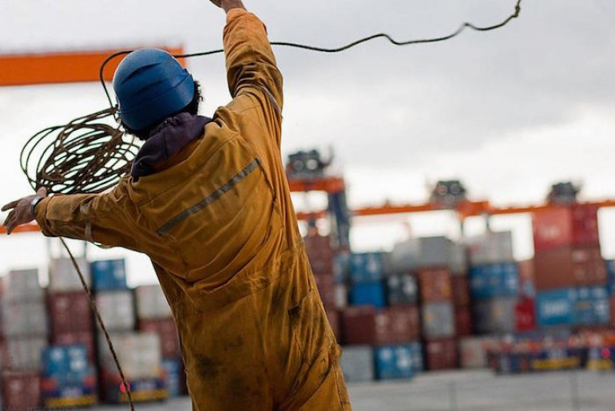

As the big four zero approaches in my life, it did seem to be a race between what’d get there first, my birthday or my waistline. Putting a sudden halt to this widening girth I’ve signed up for the London Marathon along with my fiancée Eliza. We’re now in week 10 of training and more improbably closing in one month without alcohol.
April 24 is the big day – 42 km through some of the best sights the British capital has to offer. We’re running in aid of Sailors’ Society and Eliza and I have been wowed with the generosity shown in donations to date.

Over the next couple of months in the run up to the big run I intend to do a series of Opinion pieces here to help raise more donations for this worthy cause. Haruki Murakami, the great experimental Japanese novelist, is among my favourite writers. He’s a keen runner and his memoir, What I Talk About When I Talk About Running, forms the headline basis for the series of articles I am embarking on.
Our training these days takes us through 13 km in the stunning foothills of the eastern French Pyrenees. It is hardly flat, and the elevation jumps around from approximately 450 m above sea level to 750 m so the heart gets a good pumping.
Running, as well as its obvious physical benefits, is good for the brain – it provides a decent, clear time to think. On one of my mountain assaults recently my thoughts turned to a career where exercise is seriously on the wane.
Seafaring these days has become ever more sedate, much of the daily rituals onboard are now taken up looking at screens, waiting for lights to pop up or buzzers to bleep.
On the occasions I have been at sea on commercial ships, I have eaten fantastically well (and run round the decks of VLCCs to work off the constant curry fests) but also noticed the poor shape of many sailors.
At dinner the other night, an ex-master told me how he had campaigned hard to try and get his bosses to acknowledge the risks of poor diets and limited exercise, all to no avail. Obesity, he said, was a far greater threat than alcohol onboard and yet no one paid the issue suitable attention. He even used to worry if some of his crew would be able to waddle fast enough and squeeze themselves into a lifeboat quickly if the need arrived.
I asked around some leading shipmanagers for input. Simon Doughty, ceo at Wallem, noted how obesity is definitely growing among Filipino seafarers. Wallem’s own reports suggest that 10% of all Filipino seafarers are either obese or border line before joining and it has become common to require weight loss before accepting a seafarer is fit for sea.
Doughty cites the growth in use of smartphones, video games, Facebook, web surfing taking precedence over physical sports as one of the main reasons for this development. Studies indicate that Filipinos spend 60% of their free time on video games or the web. Secondly, Doughty notes Filipinos love fast food and rice. Just a decade ago Filipinos ate three times daily. But studies show that the modern Filipino often eats and snacks nines times a day.
Whereas the average male needs 2,200 calories daily, Wallem has found that the average onboard calorie intake is nearer to 3,200.
“There has to be a focus on eating less, but better,” Doughty says.
Quite so, agree staff from the crew and catering departments at another Hong Kong manager, Fleet Management.
“Obesity is truly a growing problem for our shipping industry and it’s a matter of grave concern,” says a source at Fleet, adding: “If you expect to see a seafarer coming home after a long arduous voyage, away from family and devoid of home food, frail and tired, you are mistaken. Some of them come back home as a fat, tardy and sluggish person with more health related issues than before.”
Moreover, the dietary over indulgence onboard and related lifestyle diseases is not only a professional hazard for the seafarer himself but to the ship as well. It also costs by way of loss of man hours, reduced productivity and increased medical and insurance costs in case of sickness or an accident.
Sophia Bullard, pre-employment medical examination (PEME) director at the UK P&I Club, has worries about the obesity scourge too. In the last two years 38 crew have failed the UK P&I Club PEME on obesity grounds alone.
“Carrying excess weight causes a strain on the system,” she says, “and can also lead to other serious illness such as hypertension, type 2 diabetes, and coronary heart disease.”
233 cases of unfit crew examined in the same period by the UK P&I Club were found to be suffering from a combination of these illnesses in addition to obesity.
The onboard dietary regime has been traditionally rich in animal and dairy fats with a high intake of proteins and comparatively less of fiber in the form of vegetables, fruits and salads. Additionally, the introduction of pizzas, burgers and other fast food items, rich in fat, have also crept from shore to the ship’s menu as part of regular meals with more intake of sugary soft drinks to boot.
“Being away from family also brings in an element of loneliness in a person when one tends to eat more,” notes the Fleet source.
Anglo-Eastern Univan, as well as Fleet and Wallem, have all made dietary and exercise improvements a priority recently.
Pradeep Chawla, managing director, quality assurance and training at Anglo-Eastern Univan, says the awareness of the issues with obesity has increased and many companies as well as medical clinics dealing with seafarers are now keeping statistics about obesity. His company has even made recipe books for healthier options for Indian, Filipino and East European diets. The recipes give the calorie content of the dishes usually prepared by the cooks.
Technology – and the arrival of the smart ship – will make seafaring ever more sedentary; the industry has to act as one to change diets and attitudes now.

